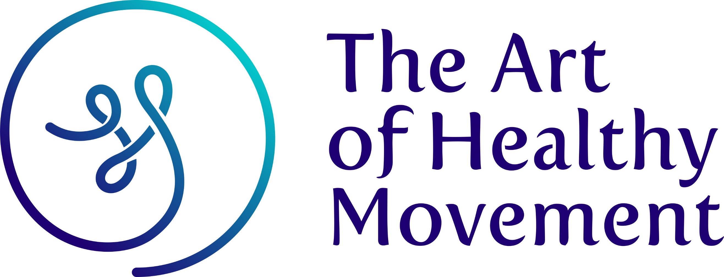


Comprehensive Teacher Training with

Fiona McIntosh
  - TERMS AND CONDITIONS

Participation & Responsibility
Whilst every effort is made to create a safe and supportive learning environment, I understand that I am responsible for my own physical and mental wellbeing throughout the training. I participate voluntarily and accept all risks associated with this programme.

Fiona McIntosh reserves the right to ask any student to leave the programme if behaviour is inappropriate, disruptive, or negatively impacts the learning environment. No refunds will be issued in such cases.

I agree to disclose any relevant medical conditions or prescribed medications prior to the start of training. Fiona McIntosh is not responsible for loss or damage to personal belongings.

Pricing, Deposits & Cancellation Policy
A £1000 deposit is required to secure a place on the course.
Remaining fees must be paid 7 days before the programme begins unless a payment plan has been arranged.
• £100 non-refundable admin fee for cancellations prior to 28 February 2026.
• After 1 April 2026, cancellation results in loss of the £1000 deposit.
• After 17 April 2026, cancellation results in a loss of £2,000.
• After 24 April 2026, cancellation results in loss of the full training fee.

If Fiona McIntosh needs to cancel the training, a refund will be provided except in cases affected by weather, political circumstances, infrastructure issues, wildlife, or acts of God.

Students must obtain their own travel insurance to cover travel or accommodation losses.

Replacement copies of training materials will be charged at £50.

Changes
Fiona McIntosh may adjust the training schedule, curriculum, or details where necessary.
Copyright All Fiona McIntosh (The Art of Healthy Movement) Teacher Training materials are protected by copyright. Reproduction is not permitted without written consent.

Signature: ___________________________ Date: ________________________________

